Civil Engineering Works Tender Price Index (CEWTPI)

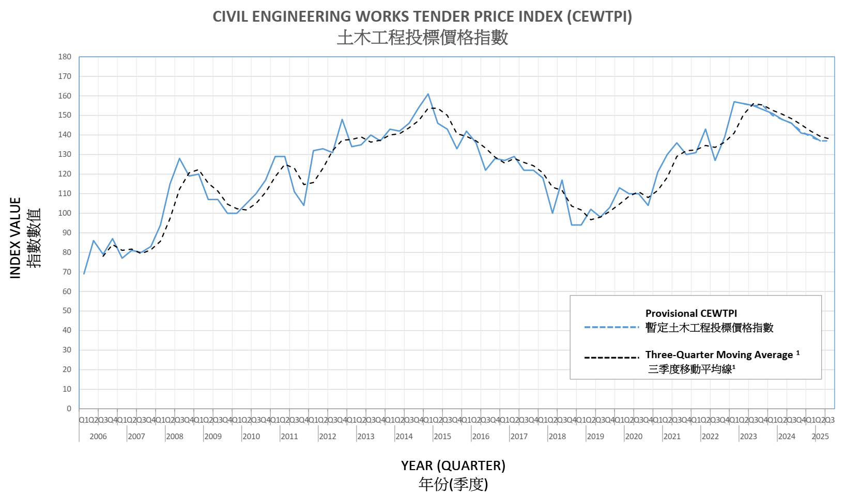

CIVIL ENGINEERING WORKS TENDER PRICE INDEX (CEWTPI)
Civil Engineering Works Tender Price Index (CEWTPI) is a quarterly index for reference of cost estimation exercises by various government works departments. It is compiled from tender pricing data of major types of civil engineering works undertaken by various government works departments. It does not cover architectural, E&M installations, ground investigation, soft landscaping, other ancillary type of works and term contract works and that may be encountered in civil engineering projects. The methodology of evaluation is developed from the principles of tracking the percentage change in prices over time for a particular basket of works items. It is extended to cover also the characteristics that are particularly adhered to civil engineering works in Hong Kong. The value in the first quarter of 2010 is taken to be the base index value of 100, and preceding and subsequent values are expressed in index form based on the first quarter 2010 value.

¹ “Three-Quarter Moving Average” showing the trend of the CEWTPI is calculated as follows:

$${ Moving Average of Quarter}_{i} = \frac{ {Index of Quarter}_{i}+{Index of Quarter}_{i-1}+ {Index of Quarter}_{i-2}}{3}$$

Year  年份 | CEWTPI  土木工程投標價格指數
Year  年份 | Qtr 1  第一季 | Qtr 2  第二季 | Qtr 3  第三季 | Qtr 4  第四季
2025 | 140 | 137 | 137  (Provisional)
2024 | 151 | 148 | 146 | 141
2023 | 157 | 156 | 155 | 153
2022 | 131 | 143 | 127 | 139
2021 | 121 | 130 | 136 | 130
2020 | 113 | 110 | 110 | 104
2019 | 94 | 102 | 98 (96) | 103 (101)
2018 | 118 | 100 | 117 | 94
2017 | 127 | 129 | 122 | 122
2016 | 142 | 136 | 122 | 128
2015 | 161 | 146 | 143 | 133
2014 | 143 | 142 | 146 | 154
2013 | 134 | 135 | 140 | 137
2012 | 132 | 133 | 131 | 148
2011 | 129 | 129 | 111 | 104
2010 | 100 | 105 | 110 | 117
2009 | 120 | 107 | 107 | 100
2008 | 94 | 115 | 128 | 119
2007 | 77 | 81 | 80 | 83
2006 | 69 | 86 | 79 | 87

N.A. | Not yet available | 暫時沒有數字
( ) | Denote figures before revision | 表示修訂前的數字

Note : CEWTPI are subject to revision upon availability of latest tender pricing data.
註釋 : 土木工程投標價格指數可能會在獲得新投標價格資料時進行修訂。

